Ibn Khaldoun University -Tiaret –
Faculty of natural and life sciences
Department of Ecology, Environment and Biotechnology

Expression &Communication Techniques Exam
January 2024
Duration: 1h30 2nd year Biotechnology

- What is the communication process? Explain the differences between the types of communication. (5pts)
- Explain how to write a research paper? (5pts)
- Discuss the conditions and sources necessary for taking notes. (5pts)
- Give a summary about the scientific topic that you have done. (5pts)

Good Luck !

Ibn Khaldoun University -Tiaret –
faculty of natural and life sciences
Department of Ecology, Environment and Biotechnology
Expression &Communication Techniques Exam
2nd year Biotechnology

- What is Communication process? Explain the differences between the types of communication. (5pts)

Communication: “Transmission of a message from a sender to receive in an understandable manner”

*The communication process is a guide to award realizing effective communication (learn to write and to speak before an audience in order to get the ability to communicate effectively).

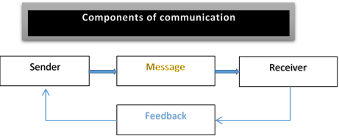

*Types of communication
1- Verbal communication: refers to the form of communication in which message is transmitted verbally, communication is done by word of mouth and piece of writing.
• Verbal communication divided into:
- Oral: spoken words, face to face conversations, speech radio….etc.
- Written signs or symbols….etc.
2-Non verbal communication: have the following three elements:
1/ Appearance:
*Speaker: clothing, hair style, neatness…..etc.
*Surrounding: room size, lighting, decoration….etc.
2/ Body Language: facial expressions, gestures, postures, eye contact…..etc.
3/ Sounds: voice tone, volume, speech rate…..etc.

- Explain how to write a research paper? (5pts)

General structure of a research paper:

* Title, abstract, keywords: make them easy for indexing and searching (informative, attractive, effective).
* Main text (follows the IMRAD format):
- Introduction: what did you or others do? Why did you do?
- Methods: how did you do it?
- Results: what did you find?
- Discussions: what does it all mean?
- Conclusion
- Acknowledgements
- References
- Discuss the conditions and sources necessary for taking notes. (5pts)
Taking notes: is to write the essential information with maximum speed.
* Conditions necessary for taking notes:
- The memory, attention and concentration, organization, structure and the economy.

*Sources of notes:
- From the oral: courses, meeting…
- From your own mental sources: memory, thinking…
- From direct observation of reality: phenomenon, experimentation…
- From a written document: magazines, books…

- Write a summary about the scientific topic that you have done. (5pts)

